**Excel Files**

* **ALWAYS ALLOW MACROS.**
* You will need to have the developer ribbon enabled. If you do not already, follow this instruction guide here: <https://www.techonthenet.com/excel/questions/developer_tab2013.php>

**Making the Schedule**

* Go to the Track Schedule sheet, still within the Numbers file. Fill in the number of heats for each event and the start time for the first event. The number of heats for the 60m and 100m will be the number of heats of Boys or Girls (whichever is greater) if we are using 2 finish lines. For all other events it is the total number of heats. Move to startline time is the time needed after the previous event to prepare for that event, which is why the first value is 0. Press “Make Schedule.”

**Making An Invoice**

* Values for the invoice will come from direct athletics. Note that the number of “entries” in direct athletics includes relay entries, so subtract the number of relays from the number of entries to get the number of individual entries.
* Go to CurrentYear Sheet. Click on the school for which you would like to make an Invoice. Then press the developer tab and press Macros. Choose MakeInvoices and press Run.
* Go to Invoice sheet. Change the Exchange rate to the value of the exchange rate on the last day of entries. Change the contact info to be yours. And change the mailing address at the top to be Primeau’s address. Then save.
* If the late Fees value didn’t work, change it manually. Then save as PDF.

**Making the Numbers**

First, note that there are several tabs at the bottom of your excel screen. When I am referring to one of them it will be in Green.

/Users/reidgustavson/Desktop/Screen Shot 2018-05-03 at 7.53.27 PM.png

* Now, go to the DirectAthleticNames and Entries sheets and delete all rows of athletes.
* For the next step you are going to need to get your entries from directathletics. See the direct athletics page below. Once you have exported the entries to excel from direct athletics, cut and paste the results into the DirectAthleticsNames sheet.
* Sometimes there are errors in this exported file, so take a quick scan down the file looking for errors. The program will not work if there are entries missing information like this picture. Fill in the blanks by looking on the directAthletics website (the same place where you pressed “export to excel”).

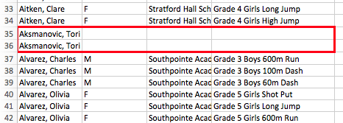

* Now move to the Entries Sheet and **SAVE**.
* Go to the top of the screen and choose the Developer option, then press the Macros button.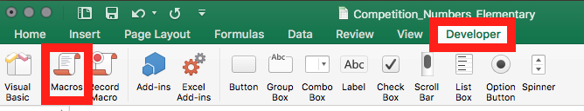
* Choose “PrepareEntries” and then “Run”. 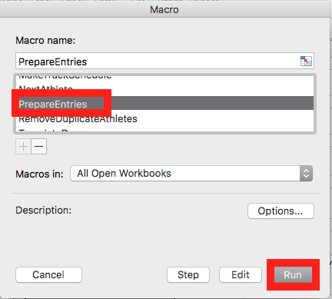
* You will see the spinning wheel of death for several minutes if you are dealing with a few thousand entries, this is totally fine. If however you get an error message asking if you would like to abort or debug, then we have a problem. Choose “Abort”. One of two things happened:
  1. You weren’t on the Entries sheet when you ran the macros and you’ve deleted all the entries. This is why we saved right before we ran. Just close excel without saving, re-open and re-run the macro from the Entries sheet.
  2. There were formatting errors in the DirectAthleticsNames sheet. Take a look at the last athlete listed in the Entries sheet, go to the DirectAthleticsNames sheet and make sure their information is formatted the same way as all other athletes. The problem athlete might be the one directly before or after that one. Once you have corrected it, go back to Entries and re-run the macro.
* At the top of the table click on school to sort ascending. This will make the next step much easier. 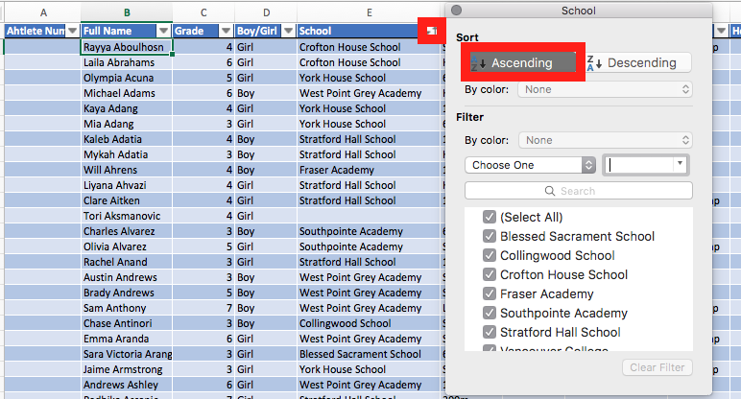
* Now go to the Heat and Lane Entry Form sheet. It should look like this (although there might still be some athlete data in it, don’t worry).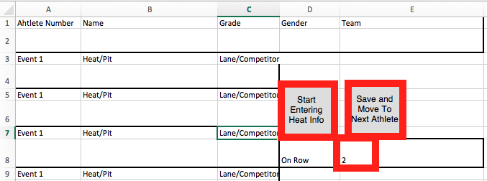
* The “2” means that we’re going to start entering athlete data from row 2 on the Entries sheet. This means if you get halfway through and want to stop, you can pick up where you left off by changing that number to the row you were on. Press the “Start Entering Heat Info” button, and you will see some of the boxes fill out. 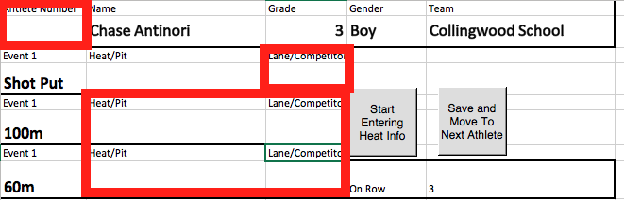
* Fill in the missing values. (Note: the first athlete sometimes is missing lots of information, don’t panic if this is the case, the rest should be fine). Don’t put Heat number for field events. The values you fill in will come from MeetPro. Inside MeetPro (assuming all races are already seeded) go to Reports, Entries by School, and check the option to include their competition number. These instructions aren’t great because I’m going by memory, so try a few things out until you have an entries sheet that you can work with.
* Now the tedious part: fill in the athlete details and press “Save and Move to Next Athlete” about 850 times.
  1. If you think you have made a mistake and want to go back change the “On Row” number to a value one or two less than it is and press “Start Entering Heat Info”. **WARNING:** If you EVER change this “On Row” value manually **DO NOT** press the “Save and Move to Next Athlete” button.
* Enter Late athletes on the Entries Sheet manually by clicking on the left column somewhere within their school group and choosing Insert. Then just fill out the fields manually for all their events. 
* Now, to actually creating the numbers! SAVE! SAVE SAVE SAVE! Before you do anything SAVE!
* Go to the Heat and Lane Entry Form. Now we will fill out these boxes.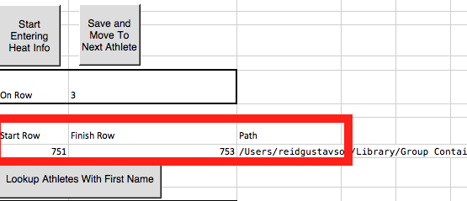
* Once again the Start Row and Finish Row refer to the row numbers on the Entries sheet. Just put 2 and 3 respectively to make sure it works for now. The path is where the files will be saved to. If you have a Mac you might be required to use a very specific path, or if you’re lucky it will default to your Desktop and you can leave this field blank. If you have a mac follow these steps to find the path that is right for you.
  1. Use spotlight in the top right corner to open up a terminal.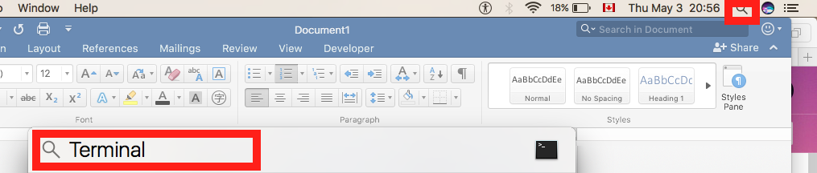
  2. Refer to this picture for steps below if you are unsure. The blue parts are the entered text. 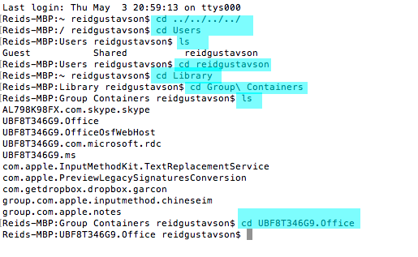
  3. If any of the following steps fail, Type “ls” and press Enter. Then try substituting the folder name with the most reasonable sounding substitute you have listed.
  4. In the terminal window type “cd ../../../../” then press Enter.
  5. Type “cd Users” press Enter
  6. Type “ls” press Enter
  7. Look for the name of your user with the highest admin privileges and then use this to type “cd YOURUSERNAME” and press enter.
  8. Type “cd Library” press Enter
  9. Type “cd Group\ Containers” press Enter
  10. Type “ls” press Enter.
  11. Type “cd UBF8T346G9.Office” if that file is listed, otherwise type “cd UBF8T346G9.ms” or whatever simple substitute is available, then press Enter.
  12. Type “mkdir Numbers” press Enter
  13. Type “cd Numbers” press Enter
  14. Type “pwd” press Enter
  15. Copy and past this value into the path of the Heat and Lane Entry Form
  16. Type “open .” press Enter. This will open a regular Finder window. Now go to File->Add to Sidebar so that you never have to navigate to it this way again ☺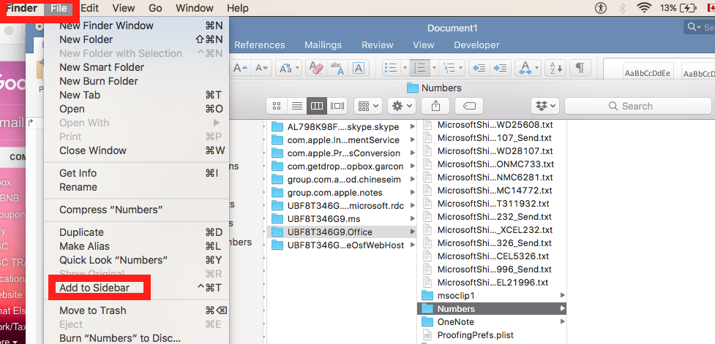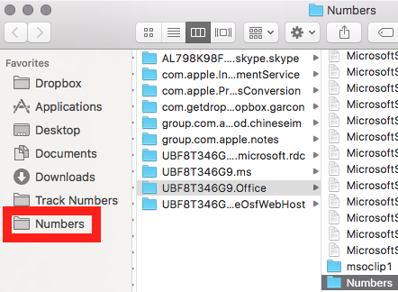
* Now, SAVE again.
* Go to the Number Template sheet. If the Thunderbirds Logo is missing, delete the skeleton of it, and insert the official logo that was given to you with the other files.
* Go to the Developer tab and press macros as we did earlier. Now choose MakeAllAthleteNumbers and press Run. Go to the finder window where you told the sheet to save and make sure there is a pdf saved there that has the correct information for the first two athletes. If this doesn’t work….fuck...email Reid I guess.
* Otherwise, go back to Heat and Lane Entry Form and change the values from 2 and 3 to 4 and whichever row is your last row with athlete information. Then repeat the previous step. You could also do this in blocks of 50 or so.
* Once they are all done, you can combine them using this tool: <https://smallpdf.com/merge-pdf> to make it easier to print them. Note that you should drag them in order and try not to drag more than 10 at a time because sometimes the website glitches and decides to miss some if you try more.
* Boom! Done.